Matter  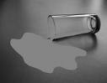 |  | Weather  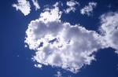
Horses  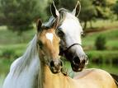 |  | Life Cycles  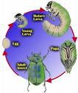
Pet Care  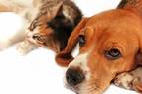 |  | Habitats  